NEWS RELEASE

FOR IMMEDIATE RELEASE Media Contact:
July 18, 2024 Amanda Weber | 760.728.1178
aweber@rainbowmwd.ca.gov

Rainbow Municipal Water District Announced Bonsall Elementary School Winners of the 2024 Student Poster Contest

FALLBROOK, CA—Rainbow Municipal Water District (Rainbow Water) announced the winners of the 2024 Water Awareness Poster Contest at the July 16 Communications and Customer Service Committee meeting. The top winners in the contest are Ivy Shadzi, Jones Titera, Lillian Nixon, and Selma Haven of Bonsall Elementary School.

Rainbow Water General Manager Jake Wiley recognized the fourth grade student artists at the meeting for their outstanding artistic achievement and presented each artist with an award, certificate, and art supplies. The four student artists will move forward to compete in the 33rd annual regional water poster contest with eleven North County water agencies. Finalists in the regional contest are then published in the 2025 calendar.

At the beginning of each year, Rainbow Water works with water agencies in North County to promote the poster contest to fourth-grade public, private, charter, and home school students. The students are tasked to help with this water awareness activity by creating an original poster with the theme "Love Water, Save Water." The posters are submitted to the contest, and water agencies vote for the best entry to be published in the following year’s calendar. The calendar is published at the end of the year, and complimentary calendars will be available to the public at the Rainbow Water office.

# # #

The Rainbow Municipal Water District is celebrating 70 years of service to the community. Founded in 1953 and organized under Section 71000 of the California Water Code, Rainbow Water provides water and sanitation services to the unincorporated San Diego County communities of Rainbow, Bonsall, and portions of Vista, Oceanside, and Fallbrook. Rainbow Water maintains over 344 miles of water main, eight pump stations, four reservoirs, and 13 storage tanks to deliver safe and reliable water to its customers.

Photo Features:
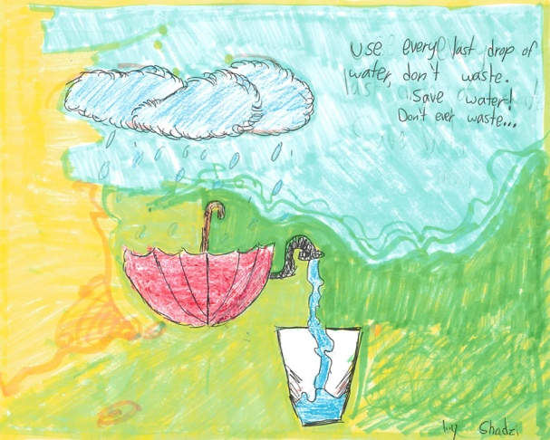
Use Every Last Drop by Ivy Shadzi, Bonsall Elementary School

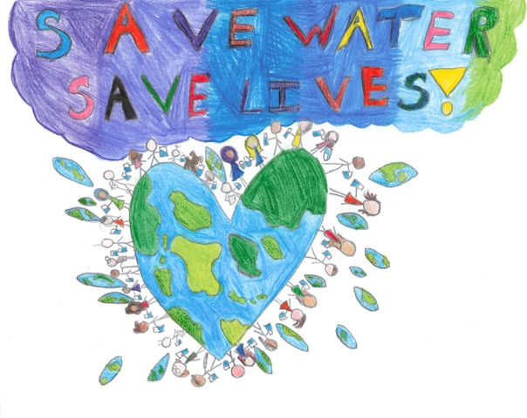
Save Water, Save Lives by Jones Titera, Bonsall Elementary School

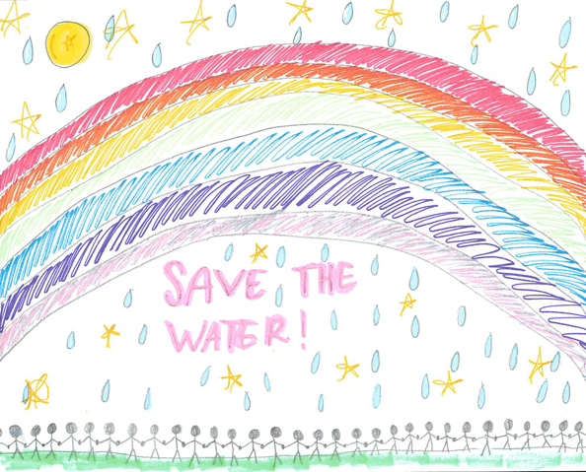
Save the Water by Lillian Nixon, Bonsall Elementary School

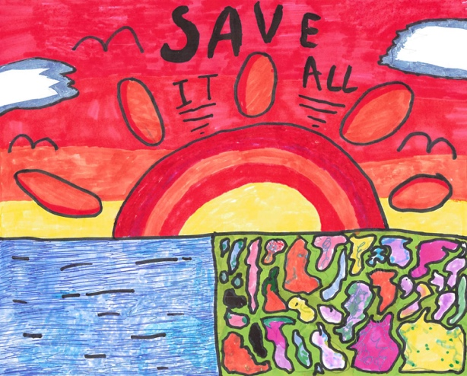
Save it All by Selma Haven, Bonsall Elementary School

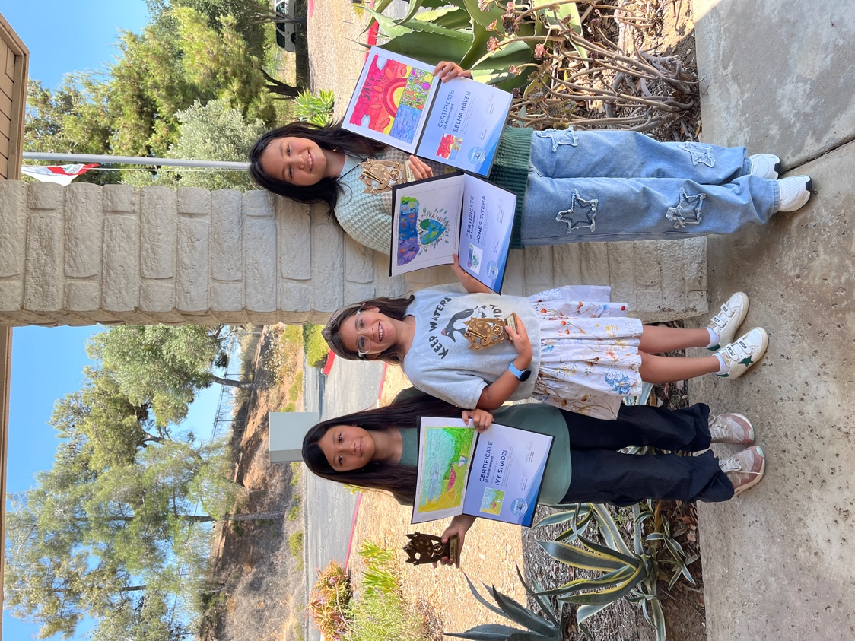
Caption: 2024 Water Poster Contest winners Ivy Shadzi, Jones Titera, and Selma Haven. (left to right).
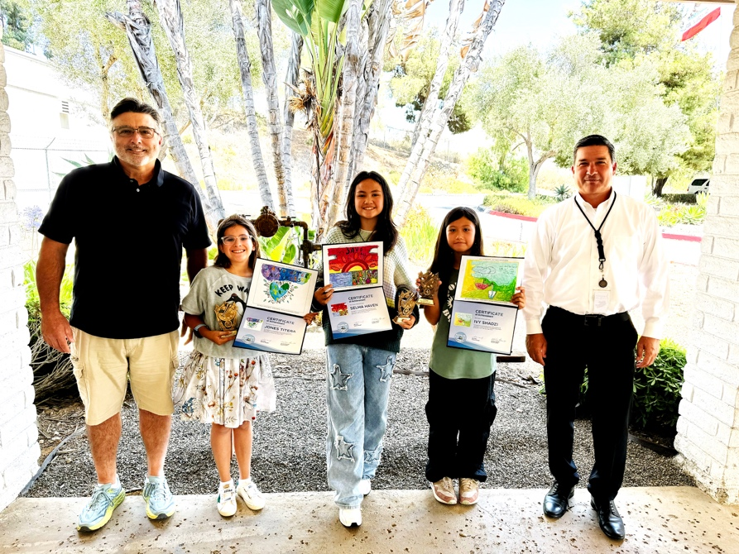

Caption: Bill Shute, Chair of the Communications & Customer Service Committee, Ivy Shadzi,10, Jones Titera,10, Selma Haven, 10, and Jake Wiley, General Manager. (left to right).

